Task 1: Set Up Your Unity Project & Configure the VR Environment [5 marks]

Open Unity Hub and create a new project using 3D template.

Name your project and choose the save location.

Install XR Plugin Management:

Go to Edit > Project Settings > XR Plugin Management.

Select the platform (e.g., Windows, Android) and install OpenXR for cross-platform VR support.

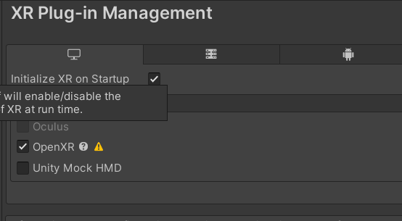

Import XR Interaction Toolkit:

Go to Window > Package Manager.

Search for XR Interaction Toolkit and install it.

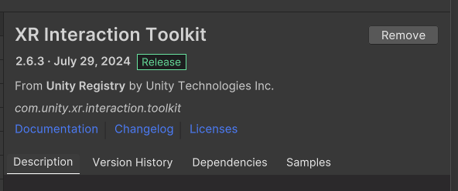

Set up XR Rig for VR movement:

Right-click in the Hierarchy and choose XR > Device-based > XR Rig.

Test VR Headset Connectivity by pressing Play and ensuring the headset displays the Unity scene.

Task 2: Create the Ground Plane [5 marks]

Right-click in the Hierarchy and select 3D Object > Terrain.

Resize the Terrain:

Click on the Terrain object and go to the Inspector panel.

Under Terrain Settings, adjust the width and length to make it larger (e.g., 50 x 50).

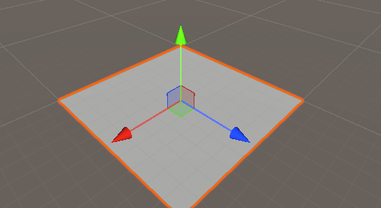

Flatten the Terrain:

Select the Paint Terrain tool in the Inspector.

Choose Set Height and flatten the terrain to 0 or desired height.

Add textures to the ground:

Select Terrain > Paint Texture and assign a ground texture (e.g., grass, dirt).

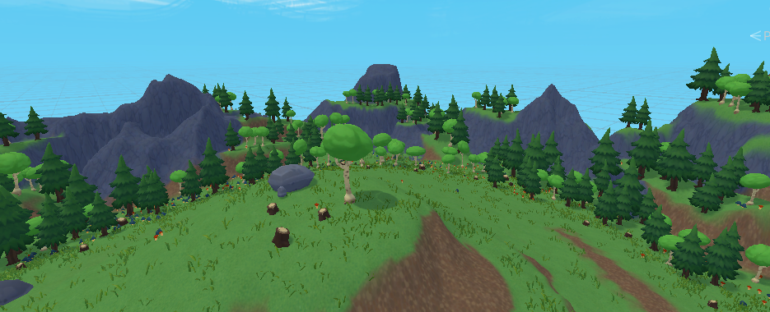

Task 3: Add a Skybox [5 marks]

Go to Window > Rendering > Lighting Settings.

In the Skybox Material field, click the circle and choose a skybox preset or import one from the Unity Asset Store.

Customize the Skybox:

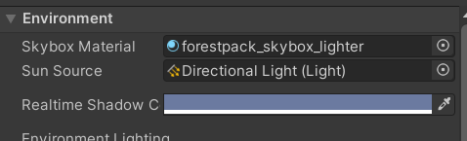

You can adjust the Exposure and Sun Intensity in the Lighting Settings for a more detailed appearance.

Test the Skybox by pressing Play to see how it looks in VR.

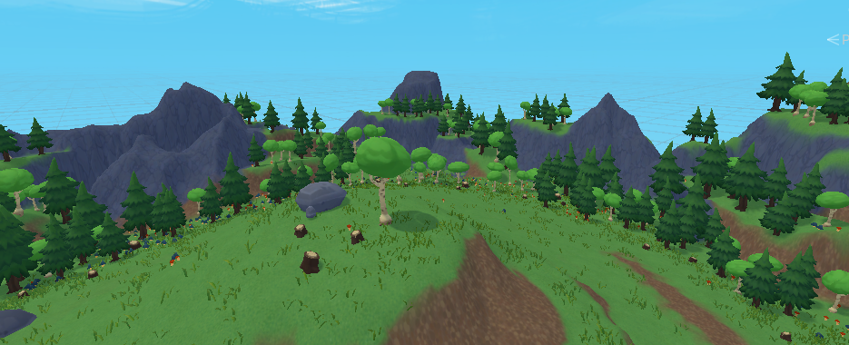

Task 4: Add Environment Objects [15 marks]

Import 3D models:

Go to Assets > Import Package > Custom Package.

Import any environmental objects (e.g., trees, rocks) from the Unity Asset Store or external sources.

Place objects in the scene:

Right-click in the Hierarchy and choose 3D Object to place objects such as trees, houses, or other assets.

Position them around the terrain for a natural environment.

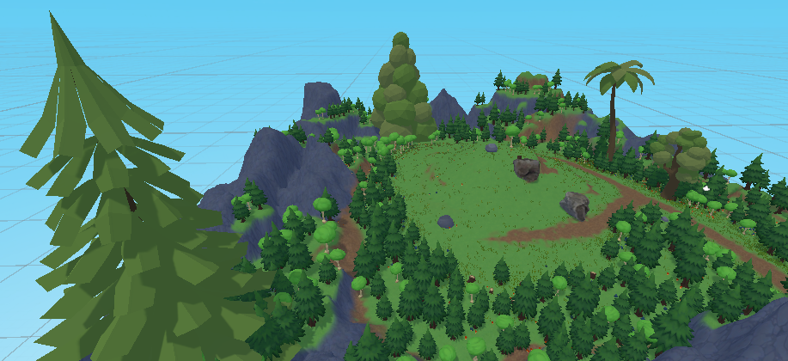

Create Grabbable Objects:

Import a 3D object (e.g., cube, ball).

Right-click in the Hierarchy, select Create Empty, and name it "GrabbableObject."

Drag your object under this Empty GameObject.

Position and Randomize Grabbable Objects:

Position the grabbable objects at various points on the terrain.

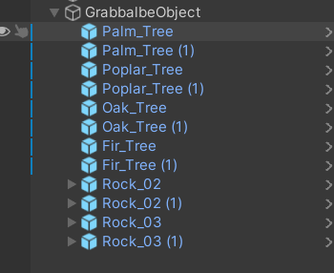

In the Inspector, manually adjust the Transform (position) values for each object to randomize the location.

Task 6: Configure Lighting and Shadows [5 marks]

Add a Directional Light:

Go to GameObject > Light > Directional Light.

Adjust its rotation to simulate sunlight.

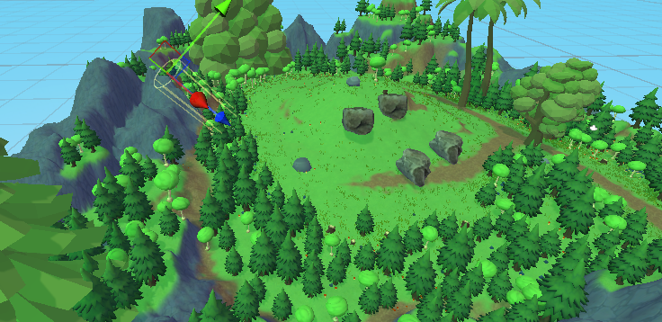

Enable Shadows:

In the Inspector, find the Shadow Type setting for the Directional Light and set it to Soft Shadows.

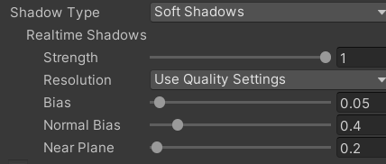

Adjust Lighting Settings:

In the Lighting Settings, adjust Ambient Light and Reflection Intensity to enhance realism.

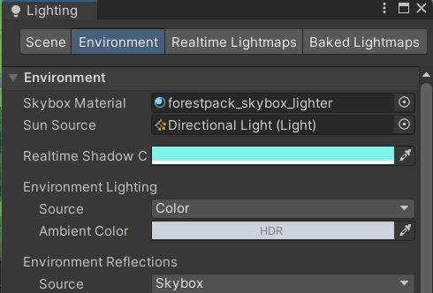

Task 7: Add Audio [5 marks]

Import an Audio File:

Go to Assets > Import New Asset and select an audio file.

Create an Audio Source:

Right-click in the Hierarchy and select Audio > Audio Source.

In the Inspector, assign your audio file to the AudioClip field.

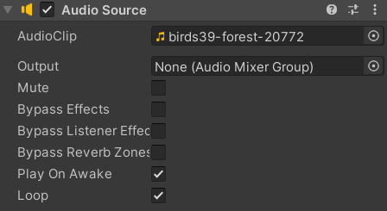

Position the Audio Source:

Drag the Audio Source to a relevant location in the environment (e.g., a waterfall, forest area).

Test the Audio by playing the scene and moving closer to the audio source.

Task 8: Implement Basic VR Interaction [25 marks]

Create a Grabbable Object:

Select one of the grabbable objects you created earlier (Task 4).

Add Components:

In the Inspector, add the component XR Grab Interactable from the XR Interaction Toolkit.

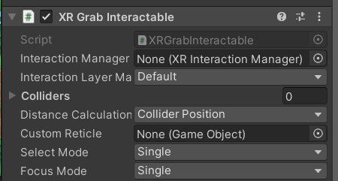

Add Grabber:

On the XR Rig, ensure you have LeftHand Controller and RightHand Controller.

Add the XR Direct Interactor component to both hand controllers.

Test Grabbing:

Press Play and test grabbing the objects in VR by moving your hands toward them.

Task 9: Write the VR Interaction Script [25 marks]

Create a Script:

Right-click in the Project panel and select Create > C# Script.

Name the script GrabObjectScript.

Write Interaction Logic:

In the script, write logic to handle object grabbing and releasing.

Use OnSelectEnter and OnSelectExit events from the XR Interaction Toolkit to manage the grabbing behavior.

Attach Script:

Attach the script to the GrabbableObject from Task 4.

Test the Script:

Press Play and test the grab/release interaction with the VR controllers.

Task 10: Demo Application

Optimize Your Scene:

Ensure your project runs smoothly by optimizing lighting, reducing unnecessary objects, and lowering the texture size.

Build Settings:

Go to File > Build Settings.

Select the platform (Windows, Android, etc.) and set the project to VR Supported.

Run the Application:

Build and run the application on the connected VR headset for a full demo.

